**DLD Lab 04 – Home Tasks**

**Task 05:**

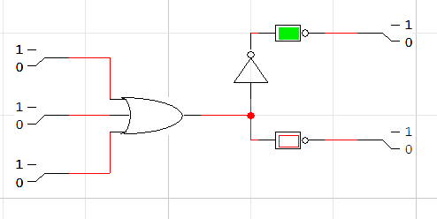

|  |  |  |  |  |
| --- | --- | --- | --- | --- |
| **A** | **B** | **C** | **A+B+C** | **(A+B+C)’** |
| **0** | **0** | **0** | **0** | **1** |
| **0** | **0** | **1** | **1** | **0** |
| **0** | **1** | **0** | **1** | **0** |
| **0** | **1** | **1** | **1** | **0** |
| **1** | **0** | **0** | **1** | **0** |
| **1** | **0** | **1** | **1** | **0** |
| **1** | **1** | **0** | **1** | **0** |
| **1** | **1** | **1** | **1** | **0** |

**Task 06:**

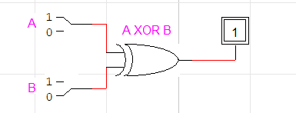

|  |  |  |
| --- | --- | --- |
| **A** | **B** | **A XOR B** |
| **0** | **0** | **0** |
| **0** | **1** | **1** |
| **1** | **0** | **1** |
| **1** | **1** | **0** |